**Practical 2**

|  |  |
| --- | --- |
| Roll No. A016 | Name: Varun Khadayate |
| Program : B Tech | Division: CsBs |
| Batch: 1 | Date of Experiment: 28-07-2020 |
| Date of Submission: 28-07-2020 | Grade : |

**(PART – A)**

***Aim: To design Deterministic finite automata using JFLAP simulation tool***

**Outcome:** After successfully competing of this practical, students will be able to learn:

* How to install JFLAP environment
* Explore various functionalities of JFLAP tool
* Designing of DFA using JFLAP tool

**A.1: About JFLAP tool**

JFLAP (Java Formal Languages and Automata Package) is instructional software for experimenting with automata and grammars, but goes further in allowing one to experiment with proofs and applications related to these topics. JFLAP’s main feature is the ability to experiment with theoretical machines and grammars. With JFLAP one can build and run user-defined input on finite automata, pushdown automata, multi-tape Turing machines, regular grammars, context-free grammars (CFG), unrestricted grammars, and L-systems. After constructing the automaton or grammar, one can trace through a single input string or receive automatic feedback on multiple inputs

**A.2: How to download and run JFLAP tool:**

* Install JDK
* Download JFLAP 7.1 version
* Copy JFLAP.zar file to desktop → right click & run using java platform

**A.3: Deterministic finite automata**

In DFA, for each input symbol, one can determine the state to which the machine will move. Hence, it is called **Deterministic Automaton**. As it has a finite number of states, the machine is called **Deterministic Finite Machine** or **Deterministic Finite Automaton.**

Formal Definition of a DFA : A DFA can be represented by a 5-tuple (Q, ∑, δ, q0, F) where −

* **Q** is a finite set of states.
* **∑** is a finite set of symbols called the alphabet.
* **δ** is the transition function where δ: Q × ∑ → Q
* **q0** is the initial state from where any input is processed (q0 ∈ Q).
* **F** is a set of final state/states of Q (F ⊆ Q).

## Graphical Representation of a DFA: A DFA is represented by digraphs called state diagram.

* The vertices represent the states.
* The arcs labeled with an input alphabet show the transitions.
* The initial state is denoted by an empty single incoming arc.
* The final state is indicated by double circles.

### **Example**

Let a deterministic finite automaton be →

* Q = {a, b, c},
* ∑ = {0, 1},
* q0 = {a},
* F = {c}, and

Transition function δ as shown by the following table −

|  |  |  |
| --- | --- | --- |
| **Present State** | **Next State for Input 0** | **Next State for Input 1** |
| **a** | a | b |
| **b** | c | a |
| **c** | b | c |

Its graphical representation would be as follows −

;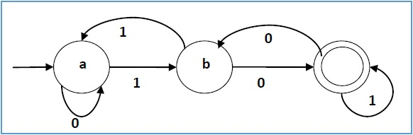

**A.4 Tasks**

1: Explore various functionality of JFLAP tool

2: Design DFA using JFLAP for the given problem:

***“Draw a DFA for the language accepting strings starting with ‘ab’ over input alphabets***

***∑ = {a, b}”***

3. Test the designed DFA using multiple inputs strings:

* abaaab
* babba
* aabaab
* abababbba

**PART B**

(PART B: TO BE COMPLETED BY STUDENTS)

**(Students must submit the soft copy as per following segments within two hours of the practical. The soft copy must be uploaded on the Portal or emailed to the concerned lab in charge faculties at the end of the practical in case the there is no portal access available)**

**B.1 Output:**

1. **Write the usage of different symbols of JFLAP simulation tool. (Take screenshots of different symbols and explain)**

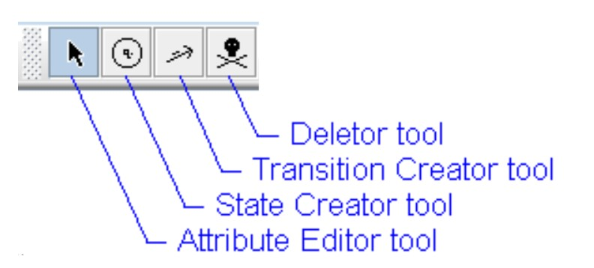

**ANS:**

**Attribute Editor Tool:**

Used for the following purposes:

* To set the **Final** and **Initial** stages.
* To move the states from one place to another.
* Changing the names of the states.
* **Adding** and **Deleting** the labels of the state.

**State Creator Tool:**

The state creator tool is used to create the states. It by itself starts from q0 and stops till the user stops.

**Transition Creator Tool:**

The transition creator tool is used to create a relation between 2 states or in the same state. When a transition is made, it has to be given an input variable on which the transition will take place.

**Deletor Tool:**

This tool is used to delete states, state labels, transitions as well as extra labels in a JFLAP file.

1. **Write the procedure to design the DFA of given problem using JFLAP tool (Design trap state too)**

**ANS:**

To design the **DFA** of given problem using **JFLAP** tool, follow the given steps:

* Open **JFLAP** tool.
* Click on **Finite Automata**. A window will open with blank space and a tool bar at the top.
* Click on the **State Creator Tool** and create 4 different states.
* Select the **Attribute Editor Tool** and arrange them in such manner that all states are clearly visible. Right click on **q0** state and select the **initial state checkbox**. Right click on **q2** state and click on **final state checkbox** .(If you wish to change the names of states, right click on the state and click on set name to change state name.)
* Draw transitions between states as follows:
  + From **q0** to **q1** on **‘a’**.
  + From **q1** to **q2** on **‘b’**.
  + From **q0** to **q3** on **‘b’**.
  + From **q1** to **q3** on **‘a’**.
  + From **q3** to **q3** on both **‘a’** and **‘b’**.
  + From **q2** to **q2** on both **‘a’** and **‘b’**.
* Arrange the states so that all states and transitions are clearly visible.
* Save the file ( Saved as Ques2.jff).

In this question, if the first input is ‘b’ or second input is ‘a’, then the automata will go to trap state where further inputs will not move the automata to final state.

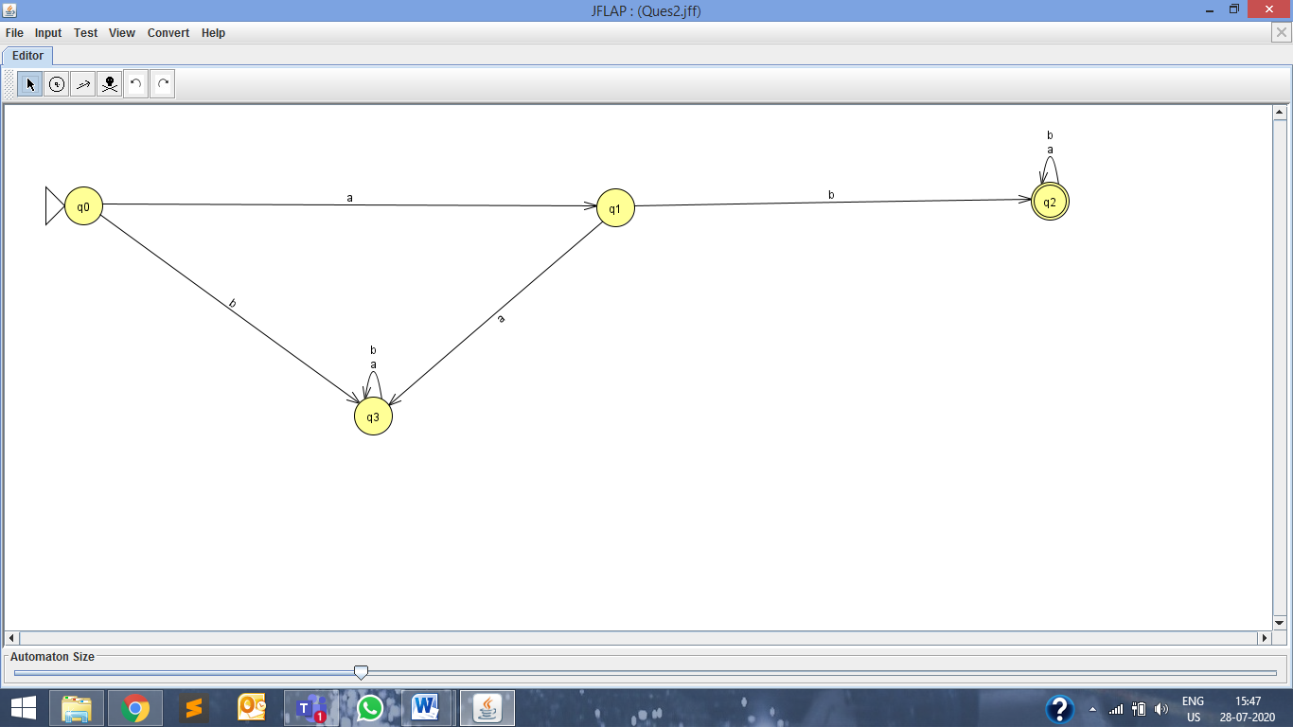

1. **Run simulated DFA by giving various input strings (as given Part A under Task section)**

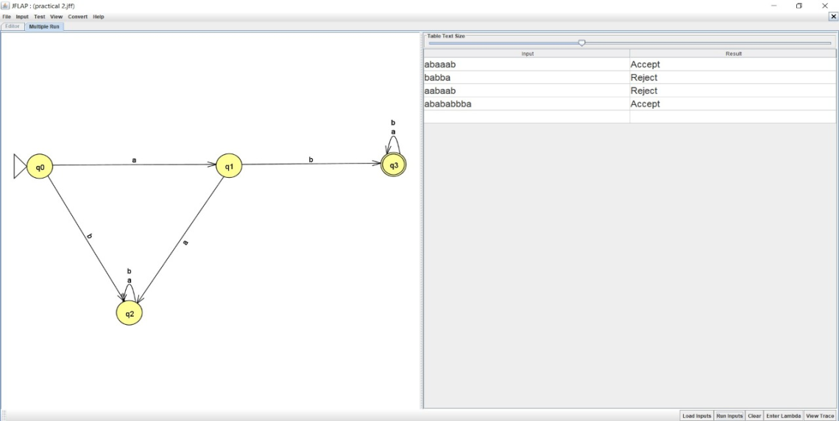

**B.2 Observations/Learning**

String ‘abaaab’ and ‘abababbba’ are accepted because in both these strings, the first input is ‘a ‘which moves the automata from initial state q0 to state q1. Second input variable in both strings is ‘b’ which moves the automata to state q2. After reaching state q2, any input will lead to same state q2 which is also the final state. Thus, both strings are accepted.

String ‘babba’ starts with ‘b’ which moves the automata from initial state q0 to state q3 which is a trap state and the automata cannot transition to final state q2. Thus, it is rejected.

String ‘aabaab’ moves the automata from state q0 to state q1 on input ‘a’ but moves to state q3 on second input ‘a’. Since state q3 is a trap state, the string is rejected.

**B.3 Conclusion:**

We were successful in creating a DFA using JFLAP tool and run multiple strings on the DFA to check whether the input strings are accepted or rejected. Out of four input strings, two strings were accepted and two strings were rejected. Accepted strings are ‘abaaab’ and ‘abababbba’ and rejected strings are ‘babba’ and ‘aabaab’.

***B.4 Curiosity Question***

***“Multiple different Transitions will not be performed by taking same input from same state in DFA” comment on the given statement***

If there are multiple different transitions from same state on same input, then the automata is not a DFA. Such an automata is a NFA where the output cannot be predicted as the automata transitions from one state to multiple different state on same input.